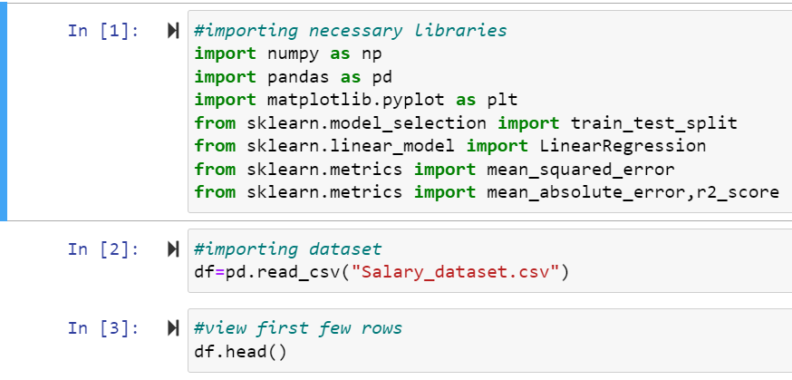

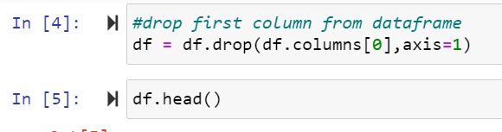

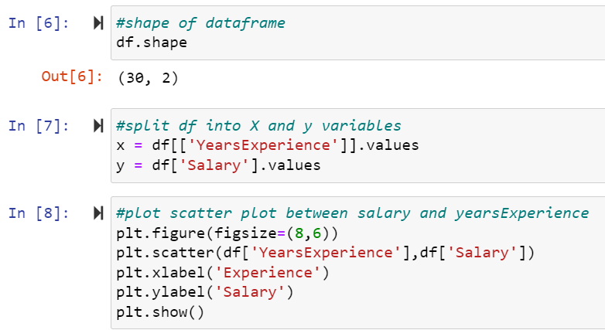

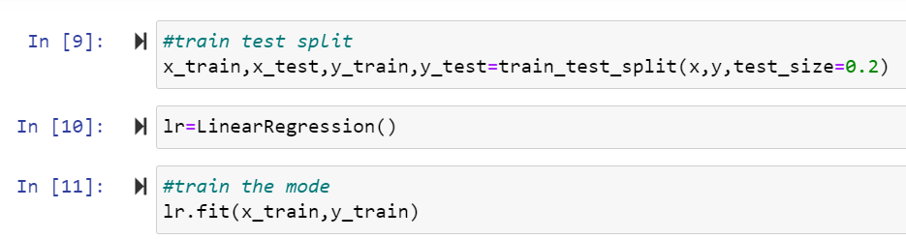

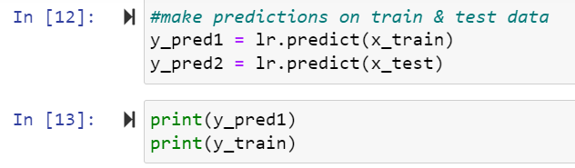

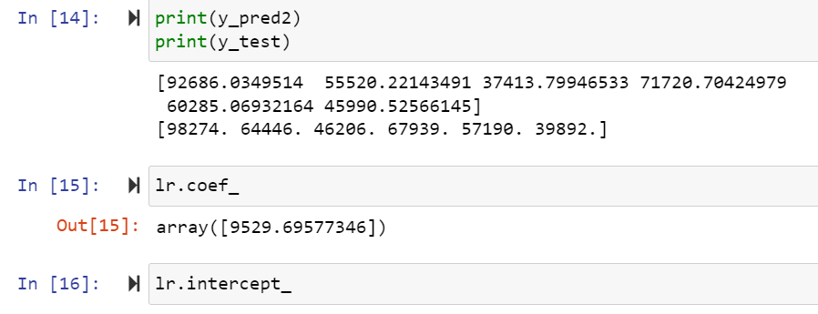

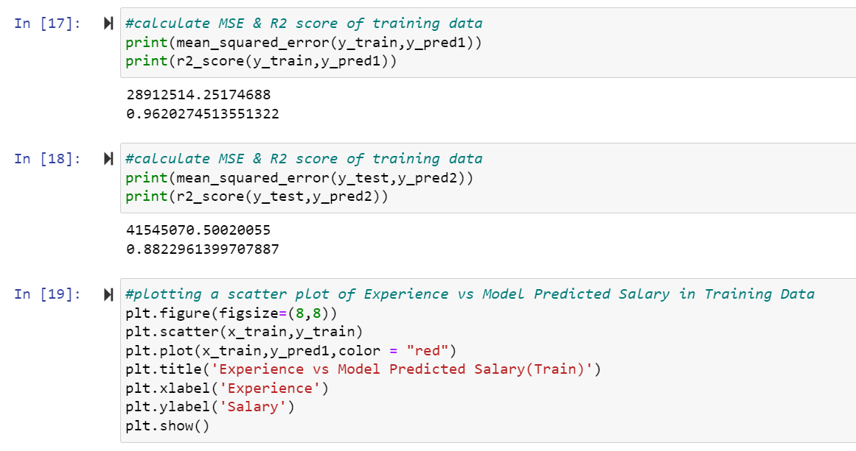

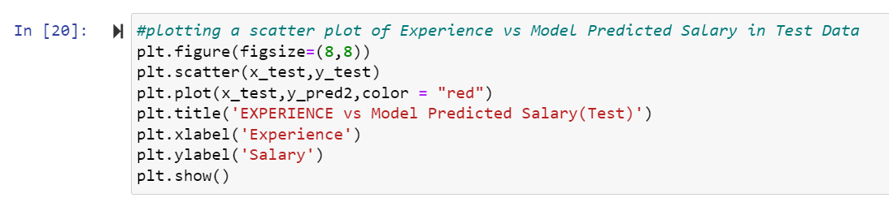

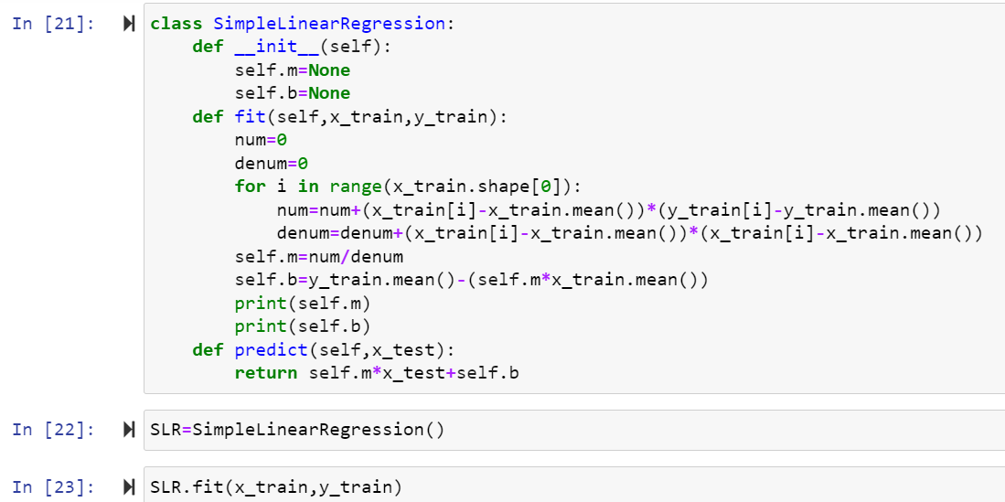

#importing necessary libraries

import numpy as np

import pandas as pd

import matplotlib.pyplot as plt

from sklearn.model_selection import train_test_split

from sklearn.linear_model import LinearRegression

from sklearn.metrics import mean_squared_error

from sklearn.metrics import mean_absolute_error,r2_score

#importing dataset

df=pd.read_csv("Salary_dataset.csv")

#view first few rows

df.head()

#drop first column from dataframe

df = df.drop(df.columns[0],axis=1)

df.head()

#shape of dataframe

df.shape

#split df into X and y variables

x = df[['YearsExperience']].values

y = df['Salary'].values

#plot scatter plot between salary and yearsExperience

plt.figure(figsize=(8,6))

plt.scatter(df['YearsExperience'],df['Salary'])

plt.xlabel('Experience')

plt.ylabel('Salary')

plt.show()

#train test split

x_train,x_test,y_train,y_test=train_test_split(x,y,test_size=0.2)

lr=LinearRegression()

#train the mode

lr.fit(x_train,y_train)

#make predictions on train & test data

y_pred1 = lr.predict(x_train)

y_pred2 = lr.predict(x_test)

print(y_pred1)

print(y_train)

print(y_pred2)

print(y_test)

lr.coef_

lr.intercept_

#calculate MSE & R2 score of training data

print(mean_squared_error(y_train,y_pred1))

print(r2_score(y_train,y_pred1))

#calculate MSE & R2 score of training data

print(mean_squared_error(y_test,y_pred2))

print(r2_score(y_test,y_pred2))

#plotting a scatter plot of Experience vs Model Predicted Salary in Training Data

plt.figure(figsize=(8,8))

plt.scatter(x_train,y_train)

plt.plot(x_train,y_pred1,color = "red")

plt.title('Experience vs Model Predicted Salary(Train)')

plt.xlabel('Experience')

plt.ylabel('Salary')

plt.show()

#plotting a scatter plot of Experience vs Model Predicted Salary in Test Data

plt.figure(figsize=(8,8))

plt.scatter(x_test,y_test)

plt.plot(x_test,y_pred2,color = "red")

plt.title('EXPERIENCE vs Model Predicted Salary(Test)')

plt.xlabel('Experience')

plt.ylabel('Salary')

plt.show()

class SimpleLinearRegression:

def __init__(self):

self.m=None

self.b=None

def fit(self,x_train,y_train):

num=0

denum=0

for i in range(x_train.shape[0]):

num=num+(x_train[i]-x_train.mean())*(y_train[i]-y_train.mean())

denum=denum+(x_train[i]-x_train.mean())*(x_train[i]-x_train.mean())

self.m=num/denum

self.b=y_train.mean()-(self.m*x_train.mean())

print(self.m)

print(self.b)

def predict(self,x_test):

return self.m*x_test+self.b

SLR=SimpleLinearRegression()

SLR.fit(x_train,y_train)